**AI POWER MANAGEMENT BLOCK diagram**

POWER SUPPLY

ESP32

LOAD

SOLAR VOLTAGE SENSOR

EB /SOLAR

SWITCHING UNIT (RELAY)

CURRENT SENSOR

EB POWER SUPPLY

SALE TO EB

L

L

**AI POWER MANAGEMENT circuit diagram**

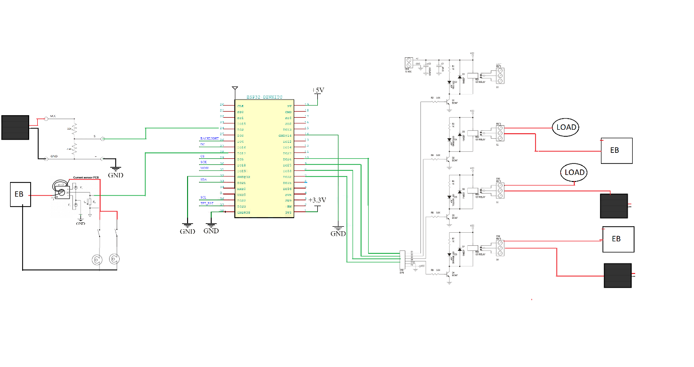

EB

